It is often the case that a dataset contains significant outliers – or observations that are significantly out of range from the majority of other observations in our dataset. Let us see how we can use *robust regressions* to deal with this issue.

**Plots**

A useful way of dealing with outliers is by running a *robust regression*, or a regression that adjusts the weights assigned to each observation in order to reduce the skew resulting from the outliers.

In this particular example, we will build a regression to analyse *internet usage in megabytes* across different observations. You will see that we have several outliers in this dataset. Specifically, we have three incidences where internet consumption is vastly higher than other observations in the dataset.

Let’s see how we can use a robust regression to mitigate for these outliers.

Firstly, let’s plot *Cook’s distance* and the *QQ Plot*:

**Cook’s Distance**

[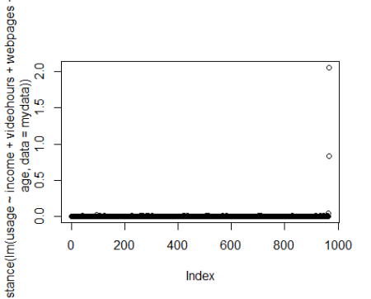](https://i0.wp.com/datascienceplus.com/wp-content/uploads/2019/02/cooks-distance.png?ssl=1)

**QQ Plot**

[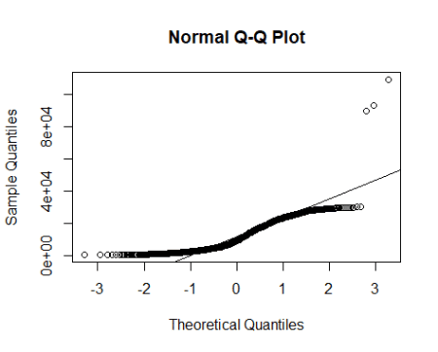](https://i2.wp.com/datascienceplus.com/wp-content/uploads/2019/02/qqplot.png?ssl=1)

We can see that a plot of Cook’s distance shows clear outliers, and the QQ plot demonstrates the same (with a significant number of our observations not lying on the regression line).

When we get a summary of our data, we see that the maximum value for usage sharply exceeds the *mean* or *median*:

summary(mydata)

*age gender webpages*

*Min. :19.00 Min. :0.0000 Min. : 10.00*

*1st Qu.:27.00 1st Qu.:0.0000 1st Qu.: 20.00*

*Median :37.00 Median :1.0000 Median : 25.00*

*Mean :37.94 Mean :0.5124 Mean : 29.64*

*3rd Qu.:48.75 3rd Qu.:1.0000 3rd Qu.: 32.00*

*Max. :60.00 Max. :1.0000 Max. :950.00*

*videohours income usage*

*Min. : 0.0000 Min. : 0 Min. : 500*

*1st Qu.: 0.4106 1st Qu.: 3503 1st Qu.: 3607*

*Median : 1.7417 Median : 6362 Median : 9155*

*Mean : 4.0229 Mean : 6179 Mean : 11955*

*3rd Qu.: 4.7765 3rd Qu.: 8652 3rd Qu.: 19361*

*Max. :45.0000 Max. :12000 Max. :108954*

**OLS Regression**

Let’s now run a standard OLS regression and see what we come up with.

#OLS Regression

summary(ols <- lm(usage ~ income + videohours + webpages + gender + age, data = mydata))

*Call:*

*lm(formula = usage ~ income + videohours + webpages + gender +*

*age, data = mydata)*

*Residuals:*

*Min 1Q Median 3Q Max*

*-10925 -2559 -479 2266 46030*

*Coefficients:*

*Estimate Std. Error t value Pr(>|t|)*

*(Intercept) -2.499e+03 4.893e+02 -5.107 3.96e-07 \*\*\**

*income 7.874e-01 4.658e-02 16.903 < 2e-16 \*\*\**

*videohours 1.172e+03 3.010e+01 38.939 < 2e-16 \*\*\**

*webpages 5.414e+01 3.341e+00 16.208 < 2e-16 \*\*\**

*gender -1.227e+02 2.650e+02 -0.463 0.643*

*age 8.781e+01 1.116e+01 7.871 9.50e-15 \*\*\**

*---*

*Signif. codes: 0 ‘***’ 0.001 ‘**’ 0.01 ‘*’ 0.05 ‘.’ 0.1 ‘ ’ 1*

*Residual standard error: 4113 on 960 degrees of freedom*

*Multiple R-squared: 0.8371, Adjusted R-squared: 0.8363*

*F-statistic: 986.8 on 5 and 960 DF, p-value: < 2.2e-16*

We see that along with the estimates, most of our observations are significant at the 5% level and the R-Squared is reasonably high at 0.8371.

However, we need to bear in mind that this regression is not accounting for the fact that significant outliers exist in our dataset.

**Cook’s Distance**

A method we can use to determine outliers in our dataset is *Cook’s distance*. As a rule of thumb, if Cook’s distance is greater than **1**, or if the distance in absolute terms is significantly greater than others in the dataset, then this is a good indication that we are dealing with an outlier.

#Compute Cooks Distance

dist <- cooks.distance(ols)

dist<-data.frame(dist)

]s <- stdres(ols)

a <- cbind(mydata, dist, s)

#Sort in order of standardized residuals

sabs <- abs(s)

a <- cbind(mydata, dist, s, sabs)

asorted <- a[order(-sabs), ]

asorted[1:10, ]

*age gender webpages videohours income usage dist*

*966 35 0 80 45.0000000 6700 108954 2.058817511*

*227 32 1 27 0.0000000 7830 24433 0.010733761*

*93 37 1 30 0.0000000 10744 27213 0.018822466*

*419 25 1 20 0.4952778 1767 17843 0.010178820*

*568 36 1 37 1.6666667 8360 25973 0.007652459*

*707 42 1 40 4.2347222 8527 29626 0.006085165*

*283 39 0 46 0.0000000 6244 22488 0.007099847*

*581 40 0 24 0.0000000 9746 23903 0.010620785*

*513 29 1 23 1.1111111 11398 25182 0.015107423*

*915 30 0 42 0.0000000 9455 22821 0.010412391*

*s sabs*

*966 11.687771 11.687771*

*227 4.048576 4.048576*

*93 4.026393 4.026393*

*419 3.707761 3.707761*

*568 3.627891 3.627891*

*707 3.583459 3.583459*

*283 3.448079 3.448079*

*581 3.393124 3.393124*

*513 3.353123 3.353123*

*915 3.162762 3.162762*

We are adding *Cook’s distance* and *standardized residuals* to our dataset. Observe that we have the highest Cook’s distance and the highest standaridized residual for the observation with the greatest internet usage.

**Huber and Bisquare Weights**

At this point, we can now adjust the *weights* assigned to each observation to adjust our regression results accordingly.

Let’s see how we can do this using *Huber* and *Bisquare* weights.

**Huber Weights**

#Huber Weights

summary(rr.huber <- rlm(usage ~ income + videohours + webpages + gender + age, data = mydata))

*Call: rlm(formula = usage ~ income + videohours + webpages + gender +*

*age, data = mydata)*

*Residuals:*

*Min 1Q Median 3Q Max*

*-11605.7 -2207.7 -177.2 2430.9 49960.3*

*Coefficients:*

*Value Std. Error t value*

*(Intercept) -3131.2512 423.0516 -7.4016*

*income 0.9059 0.0403 22.4945*

*videohours 1075.0703 26.0219 41.3140*

*webpages 57.1909 2.8880 19.8028*

*gender -173.4154 229.0994 -0.7569*

*age 88.6238 9.6455 9.1881*

*Residual standard error: 3449 on 960 degrees of freedom*

huber <- data.frame(usage = mydata$usage, resid = rr.huber$resid, weight = rr.huber$w)

huber2 <- huber[order(rr.huber$w), ]

huber2[1:10, ]

*usage resid weight*

*966 108954 49960.32 0.09284397*

*227 24433 16264.20 0.28518764*

*93 27213 15789.65 0.29375795*

*419 17843 15655.03 0.29628629*

*707 29626 14643.43 0.31675392*

*568 25973 14605.87 0.31756653*

*283 22488 13875.58 0.33427984*

*581 23903 13287.62 0.34907331*

*513 25182 13080.99 0.35458486*

*105 19606 12478.59 0.37170941*

**Bisquare weighting**

#Bisquare weighting

rr.bisquare <- rlm(usage ~ income + videohours + webpages + gender + age, data=mydata, psi = psi.bisquare)

summary(rr.bisquare)

*Call: rlm(formula = usage ~ income + videohours + webpages + gender +*

*age, data = mydata, psi = psi.bisquare)*

*Residuals:*

*Min 1Q Median 3Q Max*

*-11473.6 -2177.8 -119.7 2491.9 50000.1*

*Coefficients:*

*Value Std. Error t value*

*(Intercept) -3204.9051 426.9458 -7.5066*

*income 0.8985 0.0406 22.1074*

*videohours 1077.1598 26.2615 41.0167*

*webpages 56.3637 2.9146 19.3384*

*gender -156.7096 231.2082 -0.6778*

*age 90.2113 9.7343 9.2673*

*Residual standard error: 3434 on 960 degrees of freedom*

bisqr <- data.frame(usage = mydata$usage, resid = rr.bisquare$resid, weight = rr.bisquare$w)

bisqr2 <- bisqr[order(rr.bisquare$w), ]

bisqr2[1:10, ]

*usage resid weight*

*227 24433 16350.56 0.0000000000*

*966 108954 50000.09 0.0000000000*

*93 27213 15892.10 0.0005829225*

*419 17843 15700.87 0.0022639112*

*707 29626 14720.97 0.0264753021*

*568 25973 14694.59 0.0274546293*

*283 22488 13971.53 0.0604133298*

*581 23903 13389.67 0.0944155930*

*513 25182 13192.86 0.1072333000*

*105 19606 12536.39 0.1543038994*

In both of the above instances, observe that a much lower weight of *0.092* is assigned to observation *966* using Huber weights, and a weight of 0 is assigned to the same observation using Bisquare weighting.

In this regard, we are allowing the respective regressions to adjust the weights in a way that yields lesser importance to outliers in our model.

**Conclusion**

In this tutorial, you have learned how to:

* Screen for outliers using Cook’s distance and QQ Plots
* Why standard linear regressions do not necessarily adjust for outliers
* How to use weighting techniques to adjust for such anomalies

If you have any questions on anything I have covered in this tutorial, please leave a comment and I will do my best to address your query. You can also find a video-based tutorial on this topic here.

**Dataset**

[internetoutliers.csv](http://www.michaeljgrogan.com/wp-content/uploads/2018/07/internetoutliers.csv)